v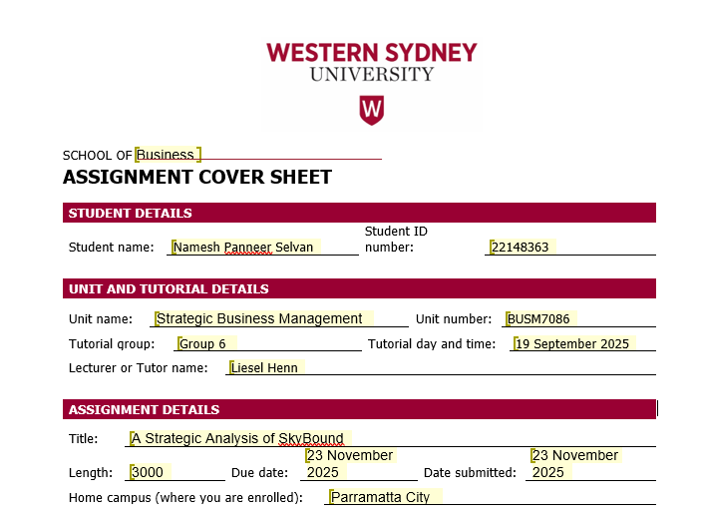
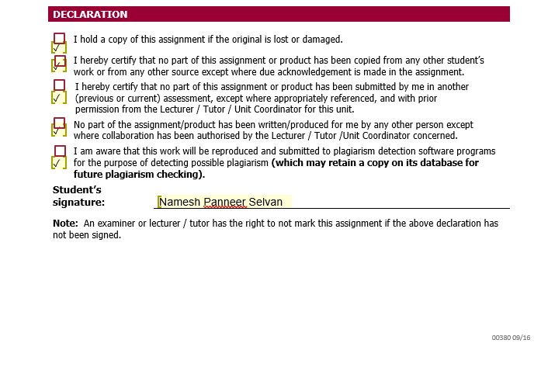

A Strategic Analysis of SkyBound

Executive Summary
This report presents a strategy analysis of the performance of SkyBound in a simulation of a dynamic and safety critical and technology-intensive jetpack industry. The report will be based on the relevant strategic frameworks of de Wit (2020) and dynamic capability theory (Teece 2007) and classical perspectives of competitive strategy (Porter 1980, 1996), in order to critically assess the changing business model of the company, establish the strategic gaps, analyse the external environment, and propose the business-level and corporate-level strategies to achieve sustainable competitive advantage within one to three years.
Results indicate that the business model of SkyBound had a history of misalignment of its resource base, activity system and value proposition. Despite the fact that the company increased its physical resources, especially manufacturing capacity, it did not increase the organisational capabilities to operationalise the resources. There was no labour investment, no production was controlled by outsourcing, no quality assurance procedure was institutionalised, and no routines were ever established regarding safety. These shortcomings resulted in structural inflexibility, greater reliance on suppliers and sabotaged the firm in terms of performance and innovation value delivery on promise.
Three strategic gaps are determined:
(1) A resource-capability gap, which is characterized by the fact that physical resources were ahead of internal capabilities.
(2) An activity-system integration gap, characterized by a lack of alignment of procurement, production, and scheduling and delivery.
(3) A value-proposition execution gap, which is characterized by the lack of safety, maintenance and training capabilities.
The economic cost pressures and high supplier power were found to be the industry forces that could threaten the competitiveness of SkyBound through external analysis.
The inside-out capability-first business-level strategy that should be adopted is the strategy that emphasises the development of labour, production within the company, the coordination of operations, and the safety architecture and re-orientation of research and development towards reliability and sustainability exercises. On the corporate level, the report proposes an integrated vertical growth strategy where the vertical integration is done through backward and forward, but then the selective horizontal deepening is done after operational maturity is realised. This expansion route will increase synergy, increase stakeholder legitimacy, decrease dependency on suppliers and place SkyBound in a competitive situation to grow as the industry enters emerging maturity and leaves the early-growth stage.
By integrating both capability building, operational rigour, ESG strengthening and the sequential corporate growth, SkyBound will be able to eliminate the primary tensions of its business model and achieve a sustainable competitive advantage.
Introduction
The original strategic purpose of SkyBound was to be a multi-segment innovative player in the new jetpack business. The company defined the ambitions to offer safe, technologically advanced and customer-focused solutions in a variety of market segments: Basic, Sporty, Safe and Green. Nonetheless, its implementation was quite different as compared to these visions. According to De Wit (2020), to be strategic, there should be a concord between the mission, the vision, the resources, and the operational activities (pp. 182–200).
SkyBound grew the physical asset base without building up the labour, routines and safety systems to be able to sustain growth. This inadequacy of fulfilling the aspiration and ability forms the basis of the analysis that follows.

Findings
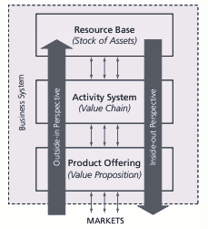
Business Model Findings
The business model of SkyBound can be evaluated in the perspective of de Wit (2020) three interdependent elements: Resource Base, Activity System, and Value Proposition. When these three elements are mutually reinforced, a strategic coherence will arise, otherwise there will be operational inefficiency and loss of competitive edge.

Resource Base (Before vs After)
SkyBound had few internal resources at the start of the simulation. The firm possessed low production capacity, lacked a committed workforce and had a limited investment in research and development. There was no labour expenditure even at the beginning or at the end, and this means there was no manufacturing of any kind, either internal manufacturing, engineering, safety or quality.
SkyBound invested in various production plants as the simulation went on. Towards the middle of the simulation, the company had three to four factories, which was a huge addition to physical capacity. But these factories could not be active without the labour that they had inside. The company was still outsourcing production, which paid higher and higher fees even though it had internal facilities. De Wit (2020) helps us realise that, without mobilising resources using developed organisational capabilities (pp. 218-220), resources cannot create value.
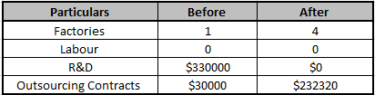
The reason why SkyBound could not invest in labour was that the base of resources grew on the surface and not in depth.
The company also failed to invest in the knowledge-based resources. There were no internal safety knowledge, maintenance procedures, operational standards or service competencies developed. The SkyBound failed to capture or convert opportunities to develop internal competence based on the dynamic capability’s perspective (Teece 2007). Its resource base was not dynamic, and the industry needed to learn at a fast rate.
Activity System (Before vs After)
The activity system at SkyBound was characterised by a lack of fragmentation, inconsistency and misalignment. Demand forecasting was frequently divorced from production decisions, procurement was non-existent with regard to scheduling, and contract fulfilment was unpredictable, as levels of output changed.

Since internal factories were not working, outsourcing was the mechanism of default, which led to bottlenecks and an increase in the rigidity of operations. Outsourcing reliance implied that the firm had a low level of control in the production schedule, quality and education. According to De Wit (2020), reinforcing linkages develop within coherent activity systems to enhance performance (pp. 196-206).
The activities of SkyBound were not reinforced.
The most critical aspects of the functional activity system, including quality assurance, compliance routines, maintenance processes, customer support, and the product feedback loop were missing. The organisation did not carry out any safety test, technical documentation or reliability monitoring. Consequently, no learning took place in the operations and the volatility in production remained.

Value Proposition (Before vs After)
SkyBound has positioned itself as a company that offers innovative, quality and safe jetpacks. The company also launched product variants that are targeted at the various categories of customers, such as the Green segment that is environmentally conscious. But due to the lack of safety process, maintenance cycle and reliability procedures, the company did not have the capacities needed to deliver on the promise made.
The jetpack clients, such as those of the aviation industry, need reliability, risk disclosures and sound safety histories. All these were absent in the internal system of SkyBound. According to De Wit (2020), this is the lack of connection between value promise and value delivery, a type of strategic disharmony (pp. 200-208).
In the same vein, the Green version did not have environmental facilitating features. The Green value proposition of SkyBound was just on the surface without investing in the reduction of emissions, efficiency gains, or sustainability processes.
Integration with Paradox Theory
The business model issues of SkyBound can be seen in terms of the paradox approach of de Wit. Most prominently:
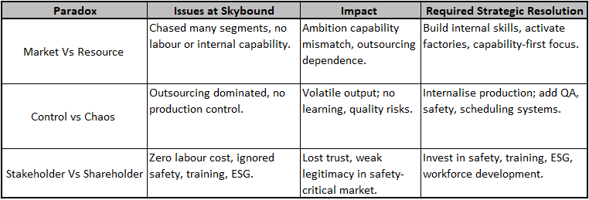

Industry Life Cycle Context
The jetpack business is in the early-growth stage, which is characterised by:
• high uncertainty in technology
• elevated costs
• new regulatory demands
• high learning needs.
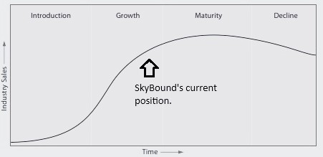
Effective companies in new technology firms develop in-house expertise, learning systems, safety procedures, and inter-functional unification. SkyBound, in turn, continued to depend on outsourcing, which was suppressing these essential growth-phase strengths.
Stakeholder Alignment
The business model of SkyBound was not in tandem with the expectations of the stakeholders. Regulators need safety arrangements; customers need reliability and training; employees need development; the environment needs sustainable ways. SkyBound undermined the stakeholder trust and long-term legitimacy by disregarding these.
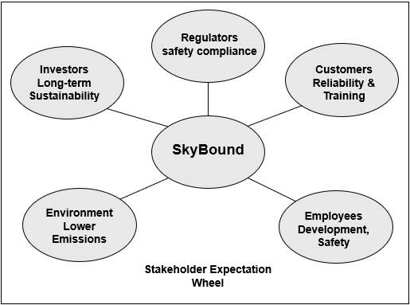

Strategic Gaps
The business model deficiencies of SkyBound converted to three main strategic gaps, namely:
(1) A resource capability gap.
(2) An activity-system coordination gap
(3) A value-proposition delivery gap.
All these gaps posed vulnerabilities to the firm that could not align itself with its most important strategic elements and, most importantly, left it with no chance to capitalise on the early-growth jetpack market.
Resource–Capability Gap
The first and most basic gap was the lack of connection between the physical resources of SkyBound and its organisational resources. Though the company has built up several production plants and higher potential production capacity, it has not invested in human capital to run the production plants. There was no increase in labour spending, with zero showing that there was no expenditure on production technicians, safety engineers, maintenance staff or quality assurance staff. Consequently, structural incapability had arisen, preventing the company from utilising its own assets.
As De Wit (2020) notes, without capabilities to mobilise resources, they are strategically inert (i.e., organisational routines, learning processes and embedded expertise) (pp. 218-220).
The physical resources available to SkyBound were never converted into productive capability, causing the company to depend on outsourcing despite having the resources.
Such a resource-capability gap is also an indication of a failure to develop dynamic capabilities. As Teece (2007) argues, dynamic capabilities allow firms to have an opportunity feeling, grab such opportunities through investing in the positions of assets and reshaping their resource base. As demonstrated by the factory building, SkyBound perceived opportunities and did not have the ability to capture or convert them through the acquisition of complementary labour skills and internalisation of production processes. The firm could not improve its efficiency or product reliability since it lacked dynamic capabilities, which left it at the mercy of the suppliers.
Activity-System Coordination Gap
The second strategic gap emerged from the fragmentation of SkyBound’s activity system. Procurement, production scheduling, inventory management and contract fulfilment were poorly aligned. Different components of the system operated in isolation rather than as a coherent network of mutually reinforcing activities.
For example:
- Production was insufficient during high-demand periods, leading to missed contract opportunities.
- Overproduction during low-demand periods increased holding costs and tied up working capital.
- R&D improvements in material efficiency were not integrated with production processes due to outsourcing dependence.
- No feedback loops existed between product usage and design improvement.
Porter (1996) argues that sustainable competitive advantage arises from systems of interlocking activities that reinforce a chosen strategic position. De Wit (2020) similarly contends that strategic coherence requires “activity fit”, alignment between tasks, resources and value delivery (pp. 196–206)
SkyBound’s activity system exhibited the opposite pattern: misfit, fragmentation and inconsistency.
This gap is common in industries in the early-growth phase, where operational learning and process refinement are crucial. Because SkyBound relied almost entirely on outsourcing, it missed opportunities to develop learning curves, improve production efficiency, and institutionalise quality routines.
Value-Proposition Delivery Gap
The last significant strategic gap was that the company was not able to meet its promised value proposition. SkyBound marketed itself as a manufacturer of safe, innovative and eco-friendly jetpacks; however, its internal procedures did not uphold this the company lacked:
• Precautionary measures and quality control.
• Pilot training systems
• Maintenance and overhaul facilities.
• Post-sales technical service.
• ESG-oriented environmental procedures.
These are not optional capabilities in aerospace adjacent markets. Customers require reliability, exposure to risks and safety standards. In the absence of these capabilities, the value proposition offered by SkyBound was dreamy and not operational. This is termed as a case of strategic disharmony, in which the firm performs poorly in linking its external message with external capability (pp. 200-208) by De Wit (2020).
The shareholder-stakeholder paradox is also manifested in this gap (de Wit 2020). By focusing on minimising costs in the short term, especially by zero labour investment, SkyBound compromised the stakeholder needs in terms of safety, reliability and training. With time, this destroyed the reputation of its products and its legitimacy as a strategy.
Business-Level Strategy Recommendation
To correct the misalignments that were established and develop sustainable competitive advantage, SkyBound should implement inside-out, capability-based business-level strategy, which will base its capabilities internally prior to increasing its market reach.
Why an Inside-Out Strategy?
An inside-out approach aims at reinforcing internal strength as the platform to base competitive positioning. The method is suggested due to the following three reasons: (1) Internal Capability Deficiencies the Underlying Cause of Performance Problems.
The incompetence of SkyBound through failures, unused factories, dependence on outsourcing, inconsistent production, and failure to offer safety value are all based on the capability gaps within the company. Unless the weaknesses are solved internally, market-driven moves will still fail.
(2) Internal Learning is needed in Early-Growth Industries.
New aviation-related products such as jetpacks are still in the early-growth stage of the industry. The successful firms in this stage achieve success through the creation of:
• learning mechanisms
• operational routines
• technical knowledge that is internal.
• safety competence
This learning is avoided through outsourcing.
(3) Market-Resource Paradox De Wit Advocates Capability-First Approach. According to De Wit (2020), companies should manage the conflict between market adjustment and resource development (pp. 238-245).
SkyBound first focused on adapting to the market without resources; the strategy will now have to shift to building capabilities.
Reestablishing Strategic Fit and Competitive Positioning.
The internal coherence is necessary in competitive positioning. SkyBound must rebrand itself as reliability-differentiated competitor, focusing on safety, performance reliability and customer service, which the competitors that employ pure outsourcing cannot duplicate.
This is positioned in line with: Safety-critical markets: expectations of customers.
• reliability is required in the early-growth industry.
• internal learning after internalisation of production.
Business-Level Strategy Operational Priorities.
In order to implement this strategy, SkyBound will have to restructure its internal operations by using five priority initiatives:
- Workforce Capability Development
Recruit and develop in-house production techs, safety engineers, quality assurance and customer service. This activates in-house factories and creates the grounds of learning and quality.
- Integrated Planning and Scheduling System
Introduce demand forecasting, procurement congruency, production scheduling and inventory management system to eradicate the disparities between the supply and demand.
- Safety, Quality and Maintenance Routines
Implement safety test procedure, in-house certification, flight approval and maintenance process. These routines help to deliver the values and minimize product risk.
- R&D Reorientation in Reliability and Sustainability
Change emphasis of R&D to reliability-oriented engineering (safety, stabilisation, propulsion, durability, etc.), and environmental (cleaner fuel use, material recovery) efforts.
- Outsourcing
The gradual elimination of outsourcing. Outsourcing must be slowly phased away as the internal capacity expands to internal production. This enhances control, enhances margins and learning.
Paradox Resolution Through the Business Strategy
The suggested business level strategy addresses some major paradoxes: The development of internal capability is now the way strategy is developed, a paradoxical situation known as market-resource paradox.
- Market-resource paradox: Strategy is now generated by internal capability development.
- Control -chaos paradox: The less the outsourcing, the more the stability in the operation.
- Stakeholder-shareholder paradox: Safety and training investments meet the expectations of the stakeholders and allow creating long-term value.
By concentrating on capability building and integration of the system, SkyBound ceases to be reactive in adapting to the market and instead, it becomes strategic in formulating its strategy.
Corporate-Level Strategy Recommendation
The corporate-level strategy of SkyBound should focus on the company structural weaknesses and provide a platform on strategic expansion within one to three years. Corporate strategy deals with level of the firm, which types of businesses it engages in, how these businesses generate joint value, and how the organisation builds its capability base (de Wit 2020, pp. 310-345).
In the case of SkyBound, the most appropriate corporate strategy is a combined strategy based on vertical integration, building capacities, forming synergies and sequential growth.
As compared to portfolio diversification which necessitates organisational maturity, strong governance systems and depth in the managerial level, SkyBound has a few internal capabilities and under developed coordination mechanisms at the moment.
Consequently, a coordinated strategy helps the company to focus its resources on the enhancement of its core value chain instead of dividing the efforts in the unrelated markets.
Why Not Diversification, but Integration?
SkyBound does not have the internal capacities required to sustain unrelated diversification or multi-business portfolio. As De Wit (2020) observes, portfolio strategies demand resource slack, coordination resources and high control systems in the organization, which SkyBound failed to achieve in the simulation (p. 326-330).
Instead, the company will need to be depth oriented rather than breadth oriented by developing an integrated group of capabilities in manufacturing, research and development, safety, maintenance as well as customer support and training.
A holistic approach is one that puts investment focus in these areas such that the focus of the managers is not diffused. In addition, the jetpack business is still in its early-growth stage, and strategic advantage is gained by technological perfection, safety reputation, internal education and client confidence, rather than in diversification into related markets.
Therefore, integration generates a more consistent corporate logic that is in line with industry maturity and internal capability requirements.

Backward Vertical Integration — The Foundation of Growth
The first priority that SkyBound needs is backward integration. It deals with the most harmful structural flaw of the firm, dependence on outsourcing. Although SkyBound owned factories, it was unable to use them since there were no labour and routine operations.
Outsourcing was thus not a strategic decision but a need-based one based on lack of capability.
Backward integration would compel SkyBound to:
✔ Recruit and develop in-house employees: Internal capacity requires the use of production technicians, safety engineers, assembly specialists and QA personnel.
✔ Internalisation of core production processes: This enables:
• better cost control
• improved responsiveness
• operational flexibility
• learning-curve gains
• reliability improvements
✔ Construct production habits and learning processes.
As soon as labour is internalized, SkyBound will be able to develop:
• standard operating procedures
• safety protocols
• checklists in quality assurance
• recycling of improvement.
Teece (2007) stresses that internalisation is one of the speeding factors in developing dynamic capabilities such as the ability to sense opportunities, capture inner efficiencies and routines transformation that goes into the long term.
✔ Reduce supplier power
This was figured out as the prevailing Porter force that was destroying margins. Structural suppliers leverage is minimised through backward integration.
Forward Vertical Integration -Methods of Enhancing Customer Value
When the operations are secured through backward integration, SkyBound ought to consider forward vertical integration as the core of enhancing competitive differentiation.
Forward integration must entail:
- Pilot Training and Certification Services:
Jetpack customers require:
• safety instruction
• operational certification
• flight procedure training
These services can help SkyBound build trust, which will result in a reputation of reliability.
- Maintenance, Repair and Overhaul (MRO) Facilities:
The aviation-proximate markets demand flight hour-based maintenance periods, depending on the conditions of use and the risk of operation. The provision of MRO services offers:
• recurring revenue
• improved customer retention
• field information on product improvement
- Infrastructure Customer Support:
The services of technical assistance, real-time digital diagnostics, and troubleshooting improve customer satisfaction and strengthen the brand of SkyBound.
The idea of forward integration is used to complement the concept of backward integration to make sure that all value chain processes, starting at the manufacturing phase and finishing with the final use of the product, are internally consistent and aligned to the overall strategic plan.

Selective Horizontal Growth: How SkyBound Will Grow Next.
SkyBound will need to expand in the horizontal direction once vertical integration has been implemented. Expanding must be discriminating, competency-based and strategically rooted.
How SkyBound Will Horizontally Expand:
✔ Reinvent current products
- Enhance Basic and Sporty models by reliability engineering.
- Enhance Safe variant differentiation through safety-first design.
- Redefine the Green model with eco-friendly materials and propulsion.
✔ Product-line extensions:
After the development of internal capabilities, SkyBound can launch:
- performance-enhanced Sporty versions
- long-range models or endurance models
- cargo or utility versions of jetpacks
✔ Segment deepening
Instead of new segments, penetration in:
- recreational flight
- personal mobility
- emergency response
- security and government markets.
This horizontal expansion corresponds to the logic of expansion described by de Wit (2020) under the coherence logic, according to which the expansion should be based on capabilities development and vice versa (pp. 338-345).
Corporate Synergy Creation
Value chain integration helps SkyBound to create synergy, the aggregate impact of operations that is greater than that which they could create independently.
Synergies SkyBound Will Consist Of:
- Cross-line product safety systems
- Combined customer support data feedback to R&D
- MRO information on product redesigning
- Standardisation in manufacturing costs variance
According to the training programmes, enhancing customer performance and minimising liability. Corporate synergy enhances the productivity of resources and speeds up the formation of a competitive advantage.
Structural Implications
First, SkyBound needs to implement functional organisational structure whereby manufacturing, R&D, safety, marketing and operations are under central leadership. With the growing capabilities, it becomes more integrated into a divisional structure, so that each jetpack line is semi-autonomous but has centralised safety and R&D systems.
This structural development sustains:
- synergy
- responsiveness
- internal coordination
- capability scaling
Corporate Responsibility (ESG)
SkyBound’s ESG stance during the simulation lacked depth, structure and strategic intent. Minimal investment in safety, labour capability, environmental management and governance systems created operational risk and damaged stakeholder trust.
De Wit (2020) notes that modern firms must balance shareholder and stakeholder needs by embedding responsibility within the strategic core, not treating it as an add-on (pp. 604–613)
ESG weaknesses included:
- No safety assurance systems
- No training for employees or customers
- No environmental reporting
- No sustainability initiatives
- No governance structures for risk, compliance or ethics

Recommended ESG Actions:
1. Establish a Safety Governance System
- Mandatory pre-flight testing
- Crash simulations
- Safety certification
- Quality assurance audits
- Flight log monitoring
This increases regulatory compliance and builds customer trust.
2. Workforce Capability & Wellbeing Investment
- Technical training
- Safety culture programs
- Skills development
- Fair employment conditions
This addresses the social dimension of ESG and supports the capability base.
3. Environmental Sustainability Program
- Improve fuel efficiency
- Reduce emissions
- Use recycled materials
- Adopt green manufacturing practices
- Publish an annual sustainability report
These actions strengthen legitimacy and align SkyBound with broader environmental expectations.
Collectively, these initiatives transform ESG into a source of long-term competitive advantage.
Conclusion
The simulation experience of SkyBound explains the extreme importance of strategic coherence. The company has increased physical resources but could not create the capabilities, routines and safety systems needed to mobilize the resources. Lack of alignment within the business model introduced structural ineffective and constrained SkyBound competitiveness in a highly cost sensitive and safety critical industry.
SkyBound needs to employ the inside-out business-level approach based on the development of capabilities, integration of operations, differentiation based on reliability and safety-related excellence to develop sustainable competitive advantage. The integrated vertical growth, at first backward, and then forward and then selective horizontal expansion, is the recommended strategy at the corporate level, when internal maturity is reached.
The latter strategies help SkyBound to address the strategic paradoxes, enhance the stakeholders trust, develop dynamic capabilities and position itself to compete in the long-term in an evolving jetpack business.
Appendices:
Appendix 1: Business Model Analysis (Full Value Chain)
- Value Chain Overview:
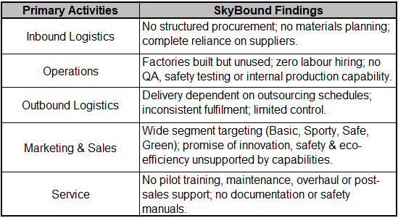
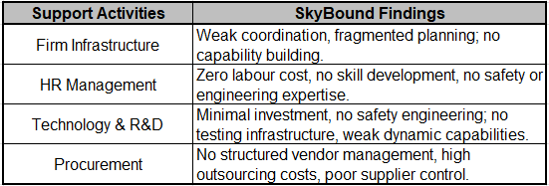

- Business Model (de Wit 2020)
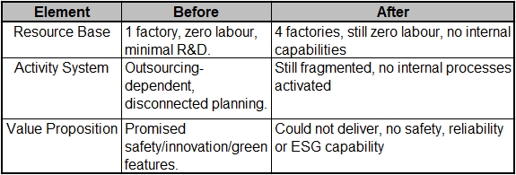
Appendix 2: Drivers of Industry Analysis
- Porters Five Forces
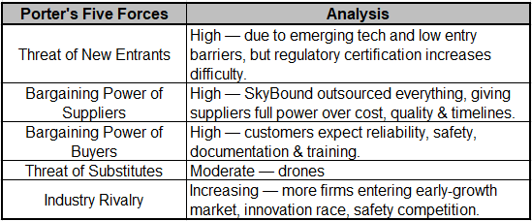
- PEST Analysis
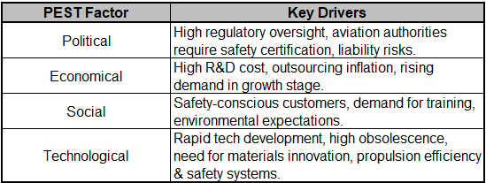

Appendix 3: SWOT Analysis
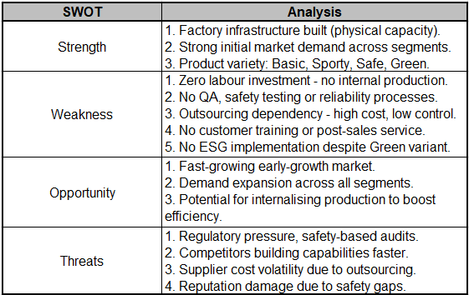
Appendix 4: Financial Ratio Analysis
- Revenue Trend per Quarter
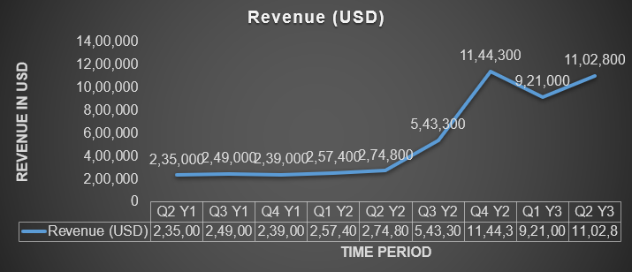

- Gross Margin (%) per Quarter
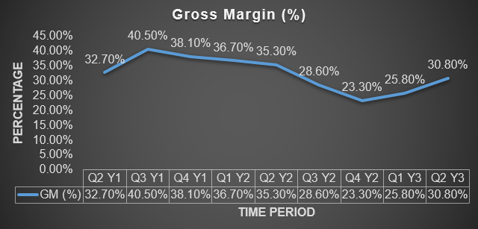
- Contribution Margin per Quarter
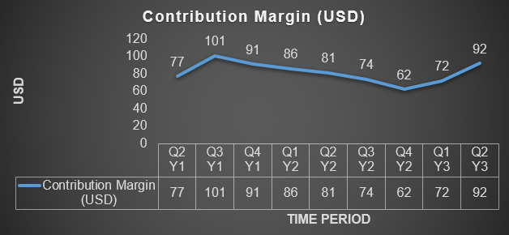

- Cost of Goods Sold (COGS) Ratio per Quarter
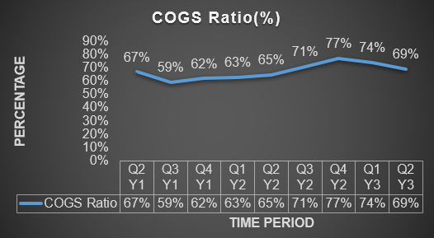
- Profitability Summary
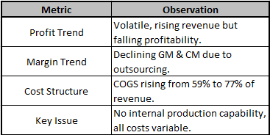
Appendix 5: Performance Outcome Analysis from the Simulation
- Internal Production Output per Quarter
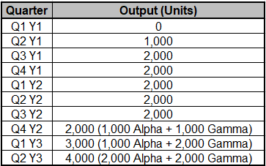

- Unit Sold per Quarter
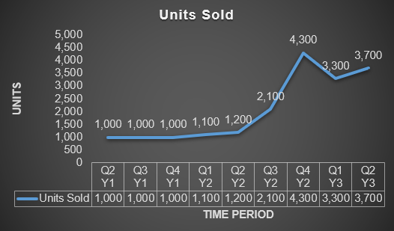
- Contract Fulfilment Performance
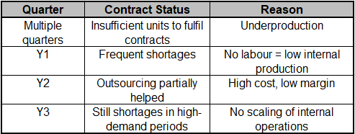
- Estimated Capacity Utilisation
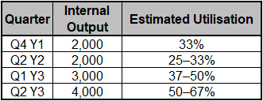
- Product Portfolio Market Share (Q2Y3)
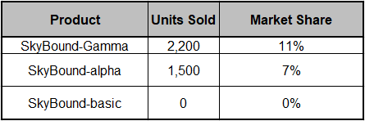
- Competitive Landscape (Q2Y3)
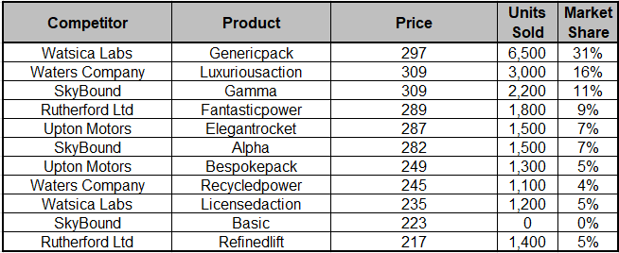
- Outsourcing Dependency
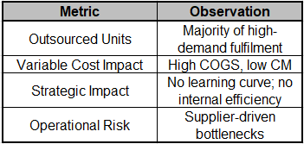
- Overall Performance Summary
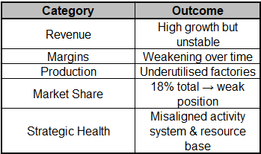

References
Barney, J 1991, ‘Firm resources and sustained competitive advantage’, Journal of Management, vol. 17, no. 1, pp. 99–120.
de Wit, B 2020, Strategy: An International Perspective, 7th edn, Cengage Learning, Andover.
Porter, ME 1980, Competitive Strategy, Free Press, New York.
Porter, ME 1996, ‘What is strategy?’, Harvard Business Review, vol. 74, no. 6, pp. 61–78.
Teece, DJ 2007, ‘Explicating dynamic capabilities: The nature and microfoundations of (sustainable) enterprise performance’, Strategic Management Journal, vol. 28, no. 13, pp. 1319–1350.

